**Exercises Tuple and List**

**Exercise 1**

Write a program to change the first and last element in a given (hard coded) list of strings. Print the List before and after the switch.



**Exercise 2**

Use a List of numbers in your program. Write a program that generates a new List that contains the same numbers but all even numbers are in the first part of the List and the odd numbers at the end.





**Exercise 3**

In this program you use a List of animal names. Write the code to move the elements of the List one place to the left.



**Exercise 4**

Use a Tuple of at least 6 numbers in your program. Write the code to create a new Tuple containing all the numbers that appear after the last digit 4. Print the original Tuple and the new Tuple.

|  |  |
| --- | --- |
|  |  |
|  |  |

**Exercise 5**

Use a List of numbers in your program.

Write a program that replaces every 0 in the list with the largest odd number you can find on the right side of that 0. If there is no odd number to be found then the 0 just remains.

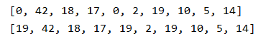





**Exercise 6**

1. Write a program to read a piece of text and save the characters (except spaces) in a List. Then print the List in three different ways.

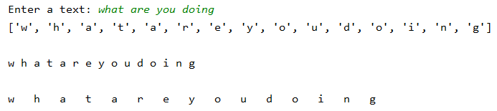

1. Extend your program so that you only put a letter of the text in the List if that letter is not already there. Also sort your List before you print it.

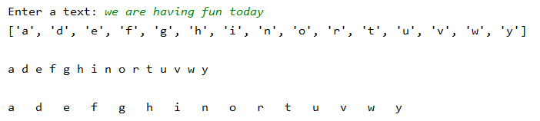

**Exercise 7**

Use a List of numbers in your program. Write a program that generates a new List that is twice as long as the original List and contains all 0. Only the last element is not 0, this contains the value of the last element of the original List.

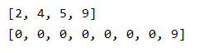

**Exercise 8**

Write a program to read the scores of a test in a List. After all scores have been read, they are sorted and the average is displayed.

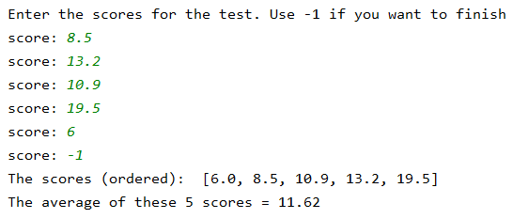

**Exercise 9**

Write a program that allows you to read the name and distance to the campus site for a group of students. This information is stored in two separate lists.

After reading, the average distance is printed as well as the student who lives the most far away from the campus.

If you want to stop entering information, type *stop* as name. Note: you may not ask how far away that person lives from the school!

If you enter *stop* immediately at the start of the program, the overview may not be printed at the bottom.

